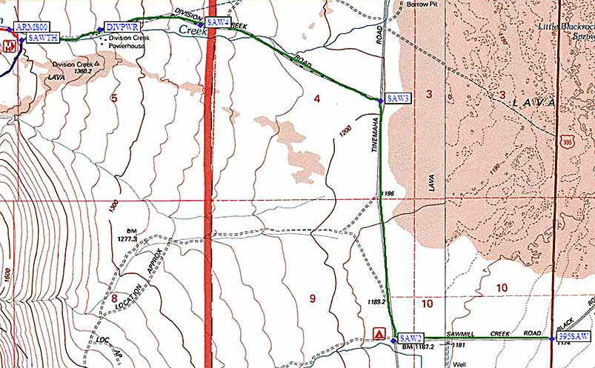
Turn west on Black Rock Springs Road (not Division Creek Road), which is marked by road name signs on each side of the highway and a large yellow 4-way intersection sign. This intersection is 18 miles south of Big Pine, 2 miles south of a rest stop, and 8 miles north of Independence.
Follow Black Rock Springs Road (the green line on the map above, which is called Sawmill Creek Road on some maps) from US-395 (waypoint 395SAW) due west to a 'T' intersection with Tinemaha Road (waypoint SAW2). Turn right (north) at the 'T' and then turn left (west again) at Division Creek Road (waypoint SAW3) where a brown sign points you to the 'Sawmill Pass Trail'. Stay on this road as it goes west-northwest through waypoint SAW4 (not a junction, just west of a cattle guard) and then west to the powerhouse at waypoint DIVPWR (where the pavement ends). Continue to the Sawmill Pass trailhead at waypoint SAWTH.

