Ritter Pinnacles 3780 m+; 12,320 ft+; 0.5 mi SSE of Mount Ritter - The highest of these pinnacles is class 3 from the southeast glacier of Mount Ritter.
Mount Ritter 4006 m; 13,157 ft
Southeast Glacier. Class 3. Go west from Lake Ediza to the cliff beneath the snout of the glacier that is southeast of Mount Ritter. Start by climbing slabs to the left of a gully before crossing the head of the gully to reach the left (south) end of a vegetation-covered ledge. This ledge leads diagonally right across the cliff; a few small waterfalls fall upon it from above. The ledge eventually splits. Go up a steep, narrow, grassy ledge before switchbacking up onto another ledge, which leads to the top of the cliff. Skirt the north side of the glacier, and climb a chute that leads to the broad talus slope beneath the summit. Clyde Variation: Class 3. The cliff beneath the glacier can be passed on its far southern (left) side. Climb toward the lowest pinnacles to the south and pass through the gap above them onto the glacier. Ascend the southern side of the glacier, keeping to the left of an ice ridge, to where a crevasse bars further progress. Cross to the north side of the glacier, over the ice ridge, to the chute that leads to the talus slope and the summit.
East Face. Class 4~5. This route is on the far left side of the east face.
Northeast Buttress. Class 4. This is the prominent buttress that rises 2,000 feet above the east cirque between Mount Fitter and Banner Peak. Climb toward the Ritter-Banner Saddle from the east to the top of the cliff that is beneath the saddle. Traverse left from the top of the cliff and climb onto the crest of the buttress. Follow the buttress to the summit.
North Face. Class 3. First ascent by John Muir. Climb to the top of the Ritter-Banner Saddle from either the east or the west. Ascend the right-hand (west) chute on the north face; it may be necessary to enter this chute from the left via a broad ledge that starts from the base of the left-hand chute on the north face of Mount Ritter. From the top of the right chute, traverse left to a wide ledge that leads up and left to an arete. Follow the arete to the summit. Starr Variation: Class 3. First ascent by Walter A. Starr, Jr. Traverse right from the top of the right chute over a ridge, then drop down onto and cross the ledges on the northwest side of Mount Ritter. Ascend the ledges to the summit. Variation: Class 3. The left chute on the north face may be preferable if there is a lack of snow.
West Slope. Class 2. Go south from Lake Catherine to the outlet of the southernmost lake of the Ritter Lakes. Follow the eastern shore of this lake toward the south, past the first talus fan and around a low buttress, to the second talus fan. Ascend this fan (a real slog) to the upper bowl. Traverse right to a chute; be sure to enter the chute about halfway up, and not from its bottom. This chute leads to another talus fan, which leads to another chute. Climb this chute until about you are 50 to 75 feet below its top. Traverse left and up to the top of the ridge, which is followed to the summit of Mount Ritter. The top of this upper chute is difficult to find during descent.
Banner Peak 3943 m; 12,945 ft
From Ritter-Banner Saddle. Class 2. This route is class 2 from Lake Catherine; a class 3 section is encountered when approaching the saddle from the east. Banner Peak is a talus slog from the saddle.
Southeast Face. Class 5.
Northwest Shoulder. Class 4. Ascend the north side of the ridge from North Glacier Pass. The last part of this climb ascends the crest of the northwest ridge
Mount Davis 3750 m; 12,311 ft
Southeast Slope. Class 2. Keep to the southwest side of the ridge while climbing the peak from North Glacier Pass.
West Chute. Class 2. There is a headwall on the southwest side of the summit of Mount Davis, with two chutes to the right (south) of the headwall. Climb the northernmost chute to the southeast slope and then on to the summit.
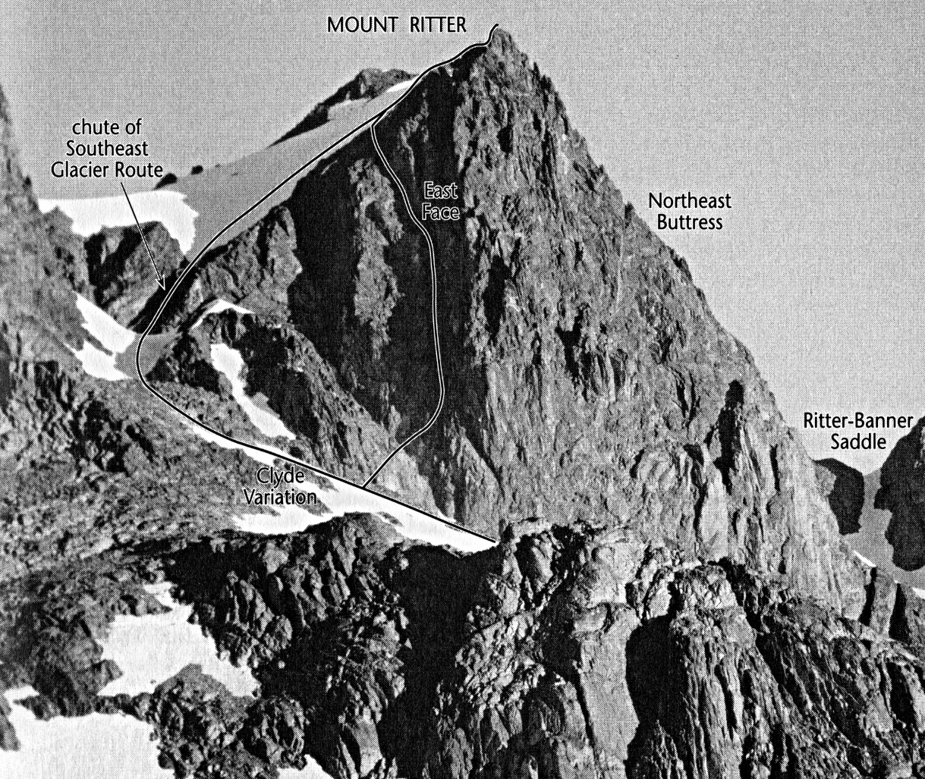
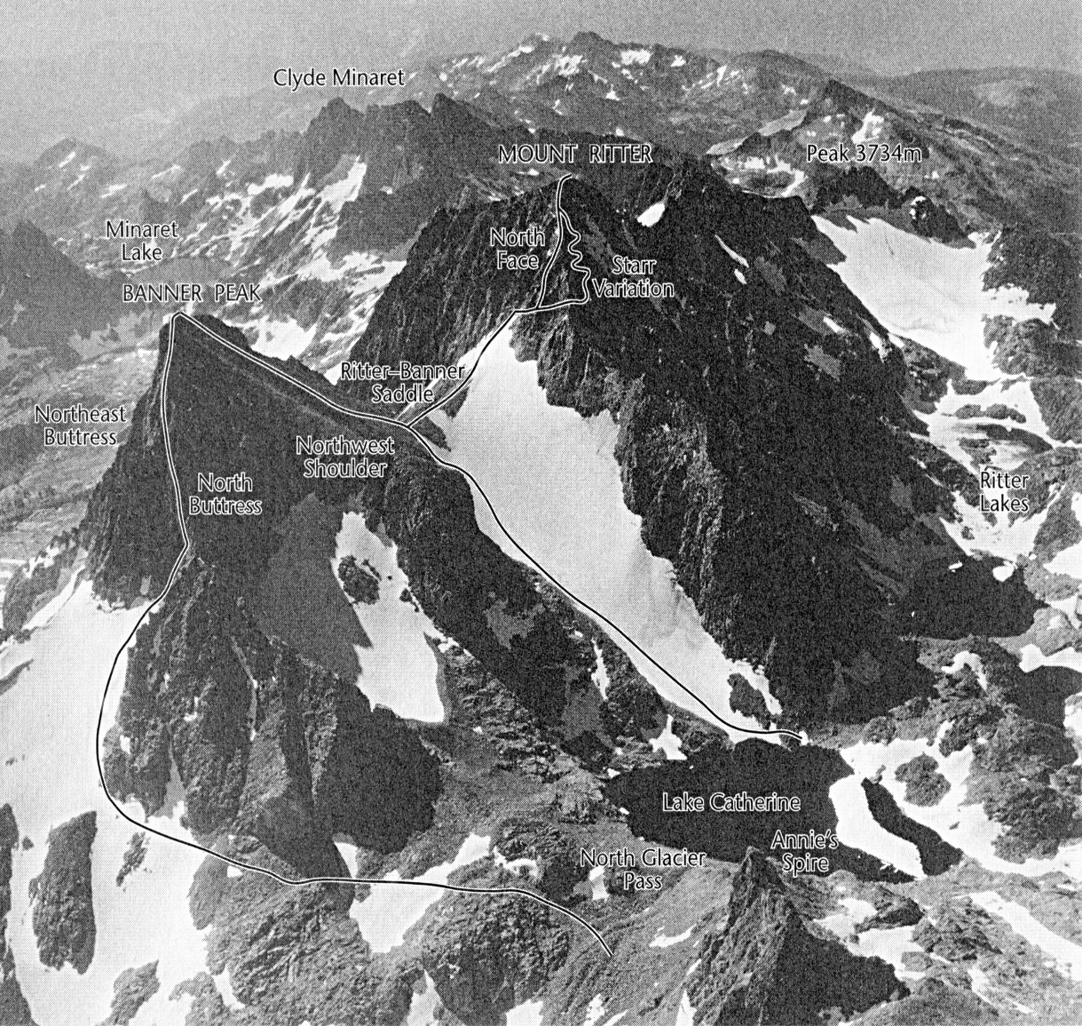
North Buttress. Class 4. This buttress is between the two glaciers on the north side of Mount Davis. Start by climbing the west side of the buttress at first, and later move onto the crest of the buttress to reach the summit.

