Longley Pass 3780 m+; 12,400 ft+ Class 1.
This is the first pass south of South Guard. The west side of the pass is easy, but the east side is a little more difficult. In early season, the east side of the pass may be blocked by a cornice. This can be bypassed on the north by means of a short class 3 section.

Brewer Pass 3860 m+; 12,640 ft+; 0.5 mi SE of Mount Brewer
Class 2. Also known as Brewer Col, this pass connects Brewer Creek with East Lake. The east side of this pass may be impassable due to steep snow. If this is the case, it can be bypassed by climbing the south ridge of Mount Brewer and descending the peak's east ridge to East Lake. In other words, it can be bypassed by traversing Mount Brewer.

Cinder Col 3680 m+; 12,080 ft+; 0.7 mi SW of Mount Brewer
Class 2. This pass has been called "Brewer Ridge." It extends from Cunningham Creek to Brewer Creek, and is usually crossed with Sphinx Col for climbs of South Guard from Sphinx Lakes.

Sphinx Col 12,040 ft+; 12,080 ft+; 0.9 mi SW of North Guard; UTM 657637
Class 2. This pass is usually used to approach Mount Brewer from Sphinx Lakes. Leave the Sphinx Creek Trail where it crosses to its west bank at a prominent meadow at 8,520 ft+. Hike up the west side of the creek to Sphinx Lakes. Head south from Sphinx Lakes and then turn southeast, climbing up to this hidden pass, the notch northeast of Peak 12,360ft+ (12,393 ft). Descend the southeast side of the pass first by heading east and then southeast into the Brewer Creek drainage. The northwest slopes of Mount Brewer can be easily reached from here.

South Guard 4033 m; 13,224 ft
North Ridge. Class 2-3. Follow the ridge from Brewer Pass.
South Slope. Class 2 from Longley Pass.

Mount Brewer 4136 m; 13,570 ft Has a wide, unobstructed view in all directions from its summit.

East Ridge. Class 2. From East Lake, follow Ouzel Creek upstream to where it is possible to climb onto the ridge that leads directly up Mount Brewer. Follow the ridge to where it ends against the south ridge of the peak; go left (south) through a small notch, and climb the south ridge to the summit.

South Ridge. Class 2. From Brewer Creek or South Guard Lake, ascend to Brewer Pass and follow the south ridge to the summit. The south ridge can also be ascended from East Lake, but the east ridge is an easier route.

Northwest Slopes. Class 2. Cross into the Brewer Creek basin from Sphinx Lakes via 'Sphinx Col," the notch northeast of Point 12,360ft+ (1 2,393 ft). Traverse and climb into the bowl between North Guard and Mount Brewer and climb the northwest slope of Mount Brewer.

Northeast Couloir. Class 2-3. Climb the prominent snow-and-ice couloir just north of the north-east face of Mount Brewer. The couloir ends along the north ridge. Climb the north ridge to the summit.

North Guard 4062m 13,327'
South Face. Class 3. There are three chutes on the southern side of North Guard. Climb the middle chute and from its top, traverse up and left to a saddle along the west ridge of the peak The traverse along the ridge to the summit involves some impressive scrambling and bouldering. Most impressive of all, however, is the large, sloping summit block overhanging the east face. Variation: It is also possible to traverse to the right onto the crest of the south ridge from the top of the middle chute.

East and North Faces. Class 4. Climb to the col north-northeast of the summit from the Ouzel Creek drainage. From the col, climb a 30-foot, V-shaped crack on the north ridge to a ledge. Traverse right (west) across broken ledges on the north face to a crack, which leads to easier rocks and the summit.
See also http://www.snwburd.com/bob/trip_reports/south_guard_1.html for north guard report

Bob Burd’s Brewer dayhike: At 9a I reached East Lake, and started cross-country, heading west at the lake's outlet. Mt. Brewer and the East Ridge are clearly visible from the lake, and it looked like route-finding would be rather easy - how had Mark gotten lost on this route, I wondered. The topo shows two creeks entering East Lake from the west, and I headed up the second labelled Ouzel Creek on the map. This was easy, nice travelling under the forest canopy, climbing granite benches softened with layers of dirt, pine needles, and other vegetation. I stayed north of the creek at all times, mostly 40-80 yards distance as I looked for the easiest route up. The creek itself seemed lined with dense vegetation that looked like much bushwhacking if I ventured too close. I had made good time reaching East Lake, 13.5mi distance from the TH in 5hrs. I mistakenly began to think I was going to cruise up Brewer in only a few more hours seeing I had but three miles to go. That turned out to be quite wrong. As I climbed up further, the obvious East Ridge of Brewer was no longer as obvious as it had been back at East Lake. I had trouble making sense of the topo, and began to question that I was following the correct creek. I convinced myself that I was following the main one to the south, but there was a major branch heading north that wasn't at all indicated on the map. Further, the contours even on the 7.5min map just weren't accurate enough to determine my location. I climbed higher on the start of the ridge that I guessed (correctly) was the East Ridge. Once above treeline, the route became clearer and the views finer. From a higher vantage point, I could see that that northern branch from Ouzel Creek drained several lakes in that direction - the same lakes that the map showed drained into the creek parallel and north of Ouzel Creek. It was soon obvious that this area hadn't been mapped carefully by the USGS - it seems they got the location of the major features right (the lakes and ridges), but then guessed on the drainage and contours. The route I took to gain the East Ridge was fairly direct but involved some easy class 3 climbing. An easier (class 2) route would have been to follow the north-branching fork past the upper lakes, and then following the drainage upstream further where it led to the easier slopes on the NE side of the East Ridge.
Mt. Brewer Mike McDermitt Kearsarge Pass at 8.30am Sunday. up to the pass in 3 hours. hour at the pass (11,750'). with binoculars I scouted Mt. Brewer's east ridge and found what looked like a good place to gain the ridge, a 'ramp' on the ridge's north side near it's east end. reached East Lake at 5.45pm.
main campsite at the foot of East Lake (9334') by the bear box was taken… across the stream then up and into the woods in a southeasterly direction, coming upon a small meadow by a stream where I stopped for the evening. It’s the small unnamed stream north of Ouzel Creek. There was a clear view of the mountain and the east ridge in the evening light.
Sullivan’s route followed between Ouzel and the unnamed stream then gained the ridge from the north side. I mainly followed Sullivan's route However there is a huge rock island between the two streams lower down, so it is unclear how one could follow between them, as he states. Ouzel Creek has a substantial tributary ('north fork') which does not appear on any topo but which drains two small lakes shown on the topo which otherwise would seem to have no drainage.
7.30am … following the small unnamed stream, and picking up traces of a use path or animal path. At a certain point the stream, rather than continuing up a gully, cascades over rocks from the top of the right (north) side of the gully. I continued up the gully a short further ways until it became feasible to climb right and out of the gully. From there I headed east towards the peak, climbing upwards over slabby rocks, turf and pines. As did Sullivan, I encountered an occasional duck. After a ways I come to a small forested area with a vigorous stream not on the map, running south towards Ouzel Creek; I have discovered the 'north fork' of Ouzel Creek. I cross it and continue eastward and steadily upward. Eventually the ridge comes into view again, including its east end and the ramp I had previously espied. The east end does not look as steep as it had previously and I consider that Sullivan may have taken the east end (he say only that they 'hopped onto' the east ridge, without further specification) but I decide to stick with my plan. The ramp itself, all talus and perhaps 400' high, is a lot steeper than I had thought, not really a ramp just an oopening in the cliffs, but I stick with my plan and proceed. At the base of the ramp is a small hidden tarn fed with a still-moving trickle that I decide is good enough to allow me to refill (this at the end of a dry year). The final 100' to 200' turns out to be very steep but not difficult class 3 but then I am on the ridge and shortly thereafter come upon a duck. No, I'm not lost! Continuing up the broad ridge on easy class 1 footing, by now the elevation is approaching 12,000' and views to the south and north are opening up when I pause for breath. Approaching the shoulder where the east ridge meets Mt Brewer's south ridge, the class 2 picks up again and the terrain steepens. A few hundred feet higher and a short class 3 section is reached. As per Secor and Sullivan, when further upward progress is blocked, there is a ledge that takes one to the left (south) to a notch; passing through it I am on the south face. From there it is a class 2 scramble to the summit. The notch had a fabulous duck, two rocks which were obviously placed by human hand but which looked like they would fall over at any moment. I gained the summit at about 1.15pm and stayed about 45 minutes. My dread at noticing the higher, class 3/4 spires immediately to the west was calmed by checking the peak register, placed by RJ Secor, who titled it "Mt. Brewer, 4136m" leaving no question that I was on the named summit since from the 7.5 topo it was clear I was on Pt. 4136m. …register entries, including a nice one from Steve Eckert leading a PCS group in 1994; he wrote, obviously on the precipice of his famous multi-year dash for the List, "I can see nothing green, but everything seems alive".
Still feeling that Secor's 'east ridge route' was different than Sullivan's, for the return I decided to try what I thought Secor's route was/is. Thus, after returning through the notch and coming back onto the east ridge, I immediately headed down to the bowl at the head of Ouzel Creek. This bowl ends at the low point of Brewer's south ridge, but continues north a few hundred feet to the foot of what in effect is the southeast chute. One cannot go straight down the southeast chute, which seems to cliff out, so I walked out the east ridge a short ways, then turned south then west as I climbed down 200' - 300' over class 2 talus into the head of the bowl. From there a short walk south brought me to Ouzel Creek and I began walking back east downstream towards East Lake. Sullivan mentions the tedious talus after a short stretch of sand, coming down from Lilley Pass to Reflection Lake, well I am sure he was being modest. The Ouzel Creek route has no short stretch of sand and an incredible amount of talus, over a longer descent. At one point I coined the phrase 'death talus' after encountering a section with very large, flat-topped talus that would be great to walk and hop about on, except that it was covered with scree and sand, so that like those marbles in the cartoons one risked a terrible fall by walking on it (so I didn't). It turns out that Ouzel Creek runs underground for a stretch of perhaps a quarter mile or more. At times of heavy flow, the underground channel must be too small to accommodate all of the water, so then water also flows on top, leaving debris on the talus. In any event, following Ouzel Creek back to East Lake is tiresome and slow, with talus occasionally broken up by manzanita. Near the bottom I left the creek and returned to my original route. For the record, from Ouzel Creek there is absolutely no visible route onto the east ridge at any point, all the way up, until the very head of the creek, i.e., where I descended off the east shoulder. As such, approaching the east ridge from slightly to the north and gaining it from its north side at or near the east end of the ridge, is IMHO by far the better route both up and down, excepting in winter/spring if snow covers the talus, or if one is in a situation where exposure is to be avoided such as severe wind or electric storms. ..passing through Brewer Pass/Col headed west (or east), would be easier by taking the ridge not the creek and either passing through the notch or going down/up (or up/down) via the east shoulder.
I returned to camp at around 6pm. The next day I was walking by 6.15am, with a 3pm ride to catch at Onion Valley. Found a large log just downstream of the East Creek/ Bubbs Creek trail intersection and crossed Bubbs Creek dry. Made it back by 2.30pm uneventfully, with the last 5= miles from the pass covered in a blistering (literally) 90 minutes. The 3-day total was 12,000' gross gain and approx. 38 miles.
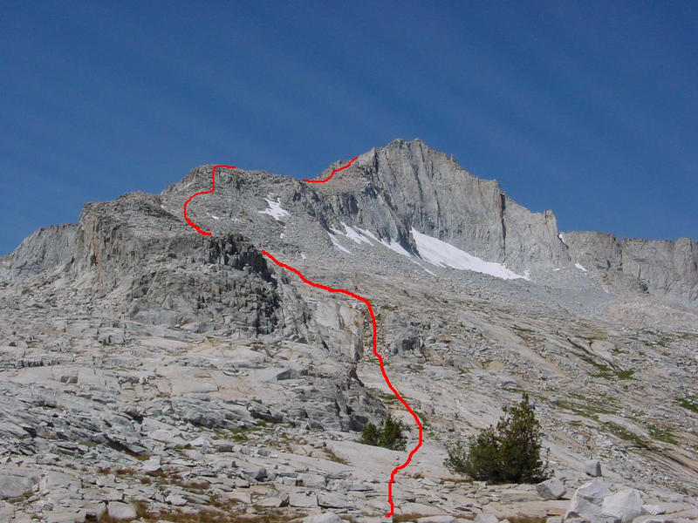
BB - It took over three hours for me to climb most of the East Ridge. It was a combination of granite ledges, large and medium size boulders, some talus. Not an exciting climb, but straightforward at least, class 2 as advertised. As I neared the top of the ridge where it joins the class 2 South Ridge, I noticed that the rock to the right steepens considerably. I could see the normal exit from the ridge, but decided to see if I could find a more elegant and direct route up the steeper face I found there. I climbed some exposed chimneys that were class 4-5, and traversed around onto the Northeast Face very near the top. Yikes! The drop-off was dramatic and nearly took my breath away. I tried two different routes to make progress, backing off the first and getting no more than a few steps up a slanting open book with a hand crack up the spine. It was probably 5.6 or so, and only about 15 feet long, but it was making me think hard and long due to the thousand or so feet my soon-to-be-lifeless body would tumble should I fall. The remoteness of the locale factored heavily, though that seems more of a psychological reason - I would have been equally dead if my body bounced a thousand feet down to the roadside. I balked and went back around the way I came, downclimbing the chimneys and returning to the easier portion of the East Ridge. I spent about half an hour in my little off-adventure, but I didn't consider it wasted time as it was pretty fun class 4-5 climbing while it lasted. Once onto the South Ridge, it was another 15 minute scramble over some large block to the summit, arriving at 1p.
…down the Northwest Slope. This is an easy descent, one I had done before, and there is no tricky route-finding - just head down the broad chute and descend boulders turning to talus. The most tedious section is near the bottom where one can't reach the bottom soon enough. After a thousand feet or so I reached the bottom where I found the gently sloping, compact sand floors much more enjoyable to travel across. I had a nice view looking up to North Guard on the other side of the canyon, and wished I had the energy for the very fun climb to the summit. That will have to wait for the South Guard - Brewer - North Guard dayhike combo some other time. :) The sandy floor gave way to granite slopes and benches as I headed down the canyon towards Big Brewer Lake. Well before reaching the lake I began to contour around the north side of the canyon which brought me to the lake just southeast of Sphinx Col. …
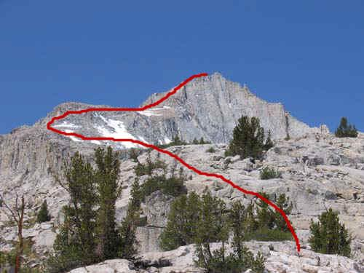
http://www.scaruffi.com/travel/brewer.html ...the East Lake trail. The eastern ridge of Mt Brewer is clearly visible from the eastern side of the lake. Once you cross the lake, it briefly disappears, but an easy reference point is the second creek (counting from north to south): Ouzel Creek. This creek descends from the left (southern) side of Brewer. From East Lake follow the second western creek (Ouzel creek) upriver for 1km. Make sure you can see the creek at all times. After about 1km you will notice a split. Follow the northern (right) branch briefly. Cross it and you have a choice: 1. You can climb the vertical wall in front of you, or 2. you can climb the much gentler slope to the north of it. Both lead to the eastern ridge of Mt Brewer. The second one is probably faster even if slightly longer. WHichever way you start, you have to climb the four "storeys" of the ridge until you reach the summit plateau. The grade is not terrifying, and Once at the plateau, one has to figure out a strategy to reach the top. Note that the summit you see from the plateau is a false summit (the real summit is now hidden behind it). If one follows the very northern edge of the plateau, a point is reached where one can zigzag to almost the top of the false summit that is visible from the plateau. This is mostly class-3 climbing. Do not attempt to reach the top of this false summit (as it is a "false" summit). Just try to get on the other side. Once on the other side, you will see the real summit, a round mound sitting on top of a vertical wall of boulders and snow. This last short ascent is not fun. The register is usually hidden under a few boulders. There are at least two more "false" summits to the east of this one.
Descending the northwestern face of Brewer is relatively easy, even if from the summit it looks vertical.
Second day: 4:30am Charlotte Meadow (2200m) 5:45am Junction Meadow/ East Creek crossing (5km, 2490m) 6:45am Crossed to the other side, breakfast break 8:00am East Lake (8km, 2886m) 8:30am Ouzel Creek 10:30am Split of Ouzel Creek, base of Eastern Ridge 11:30 Top of first storey of Eastern Ridge 12:00 Top of second storey of Eastern Ridge 13:00 Top of third storey of Eastern Ridge (summit plateau) 15:00 False summit 15:30 Summit of Mt Brewer (14km, 4136m)
left east lake at 5:30am. we used the gully well described by McDermitt in August 2001 report. We followed the marked stream North of Ouzel creek until the gully came to an end and we exited on slabs on the right side. From that point on, we headed toward Brewer's East ridge. We crossed a little forested area and went up some slabs on the lower East end of the main ridge. Our route differed from McDermitt's as we stayed close to the ridge all the way after the forested area. Up to 12,000' we stayed slightly on the North Side of the ridge top using some convenient slabs, grass and small rocks which made hiking easy. At 12,000' we crossed a 20 yard snow field to hop onto the ridge top proper. We did punch through to our knees once each and this convinced us to go around the snowfields from that point on. The three of us that were left followed the ridge top to the summit. There were snowfields which were easily avoided. It was fairly straightforward to get onto the south ridge. There were more possibilities that just the one notch described in the guide books. The three of us Linda Sun, Roger Dettloff and myself reached the 13,570' summit around 11:45am. This was a 6 hour climb as was reported by Bob and others and a bit easier than we expected based on Bob's descriptions. We located the previously mentioned gully which took us back down to East lake without brush or cliffs. We walked into camp around 6:30pm
http://www.summitpost.org/route/157004/East-Ridge.html From East Lake you can view Mt. Brewer and the East Ridge. Take visual notes, as you will not get another look at it until you are on it. Cross the outlet of the lake to the west side, and follow the shore south until you reach the second creek that empties to the west side of East Lake. This is marked Ouzel Creek on the topo maps. Climb the slopes on the north side of the creek for 1.5mi. You can head directly west to reach the East Ridge climbing some easy class 3 slopes, or for the easiest route follow the north-leading branch of Ouzel Creek that goes up to some lakes shown on the topo map. The maps are wrong about the drainage of these lakes, showing them flowing into a second creek that parallels Ouzel Creek to the north. They don't, and it can be rather confusing if you trust the map blindly. The stream goes through several lakes (last source of reliable water) and leads onto the East Ridge from a northerly direction.
Once on the ridge, route-finding is trivial. The East Ridge is a mix of granite slabs, medium and large boulders, some talus. There is no steep talus slopes to climb, making this a favored alternative to the tedious South Slopes and South Ridge. The south side of the ridge is steep in many places. As a result, you should not follow Ouzel Creek up too far and gain the ridge from the south side unless you are looking for a class 3-4 challenge. Difficulties on the ridge can always be bypassed on the right (north) side.
Where the East Ridge meets the South Ridge, look for an exit through a notch on the left. The right side exits are class 4-5, and hardly trivial. Once on the South Ridge, follow it to the summit blocks. The summit has three pinnacles. The NE one has the register, but the middle one with a class 3-4 summit block is the highest.
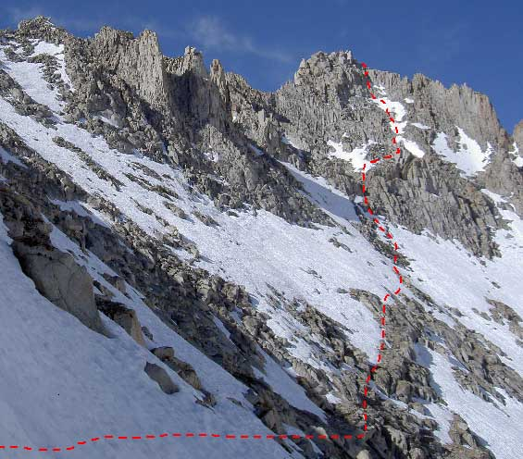
North Guard http://www.climber.org/TripReports/2006/1496.html Lisa Barboza Dates: 9-11 Jun 2006 7:00 AM. We climbed to the next paternoster lake above 10,514, then headed due south for about a mile, and then southeast for another mile to Sphinx col. we settled on a northeasterly course to the next small ridge, and then a northeasterly course to the summit. We stayed on the snow for much of the time, transitioning to rock when a good way was obvious. There was a clear line of CL2 to low CL3 rock to follow to a small gendarme about 1/3 mile west of the summit block. We went above the gendarme on easy CL3 climbing up the 3rd gully to the summit block. At the base of the summit block, we were still in CL3 climbing.. Going out to the pillar is really two CL3 friction steps with an excellent handhold on the pillar. another route down, where we tried to go down the 4th gully, only to determine that we were better off going around the gendarme and following our original route back to the col. Our small party of 5 ended up at camp at 7:30 PM
11 June 2006 After some discussion after our late start, we elected to not climb Mt. Francis Farquhar and hike directly out. Our 9 am departure put us back at the trailhead at 415 PM, after a long downhill tramp of
about 9 miles. All in all, a great, fun, early season climb with lots of snow.

