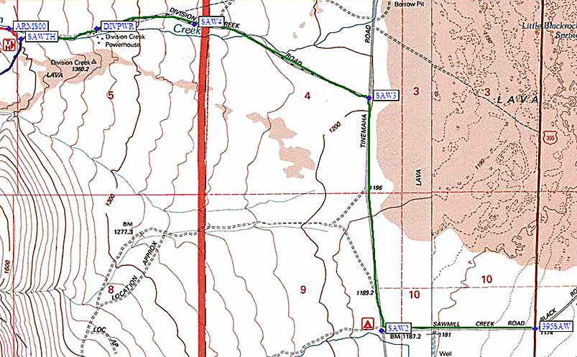
Turn west on Black Rock Springs Road (not Division Creek Road), which is marked by road name signs on each side of the highway and a large yellow 4-way intersection sign. This intersection is 18 miles south of Big Pine, 2 miles south of a rest stop, and 8 miles north of Independence.
Follow Black Rock Springs Road (the green line on the map above, which is called Sawmill Creek Road on some maps) from US-395 (waypoint 395SAW) due west to a 'T' intersection with Tinemaha Road (waypoint SAW2). Turn right (north) at the 'T' and then turn left (west again) at Division Creek Road (waypoint SAW3) where a brown sign points you to the 'Sawmill Pass Trail'. Stay on this road as it goes west-northwest through waypoint SAW4 (not a junction, just west of a cattle guard) and then west to the powerhouse at waypoint DIVPWR (where the pavement ends). Continue to the Sawmill Pass trailhead at waypoint SAWTH.
Sawmill Creek:
From the town of Big Pine drive 17.5 miles south or from Independence 8.6 miles north on US 395. Turn west on a dirt road marked Black Rock Springs Road. Drive .8 miles to a junction. Turn right (north) and follow Old US 395 (Tinemaha Road) for 1.2 miles to Division Creek Powerhouse Road. Turn left (west) and drive for 1.5 miles to the powerhouse and trailhead.
Sawmill Pass Trail: (EL 4,600')13.5 miles. Strenuous. 6,749' elevation gain. This trail passes through the California Bighorn Sheep Zoological Area where there are hiking restrictions. The trail begins near the Division Powerhouse where after some elevation gain of 1,200' and 1.75 miles it meets with the stock trail. The trail then climbs steeply up, crossing several streams to after 6.5 miles Sawmill Lake (10,023'). Continuing past Sawmill Lake for a steep climb of 1.75 miles and 1,324' to the top of Sawmill Pass (11,347').
No water on the first 4 miles of trail.Road number: 12S01
Stock trailhead is approximately 5 miles south through closed gate.
Nearest campground: Goodale Creek Campground

